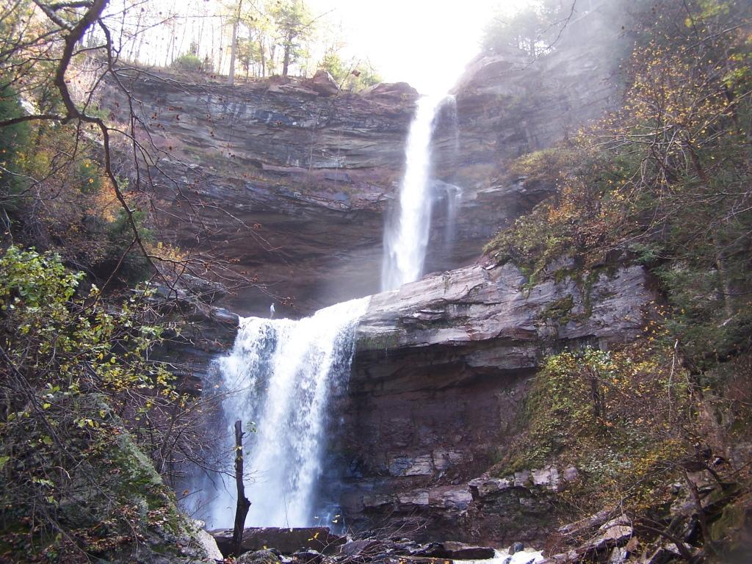
Haines Family Newsletter

36th Annual Family Reunion Picnic
& Meeting scheduled for Jul 30, 2022
North Lake Pavillion
Business meeting at noon with lunch to follow.
We’ll have meat for the grill - you bring a side or dessert for the sharing table.
RSVP by Jul 25, 2022to hainesfamilyfarm@gmail.com

Haines Family Members and Friends,
Although we are living through unprecedented times, in some ways, it seems that some normalcy refuses to be kept at bay. As a family, our indomitable spirit will not be held back. Since the founding of the Haines Family Association 36 years ago, we have striven to celebrate what it means to be part of a lineage that cannot be defeated, despite even the roughest Touraine! We are the Haines family, we tame mountains! This year we will celebrate our 36th Annual Haines Family Reunion Picnic on July 30, 2022 in the cradle of the mountaintop community of Haines Falls, at North Lake. Understanding everything we have gone through over the last few years makes it even more important for us to attend this year’s reunion, to reconnect and celebrate one another while the world affords us another day.
News
The Haines Family held its annual road-side cleanup on May 28, 2022. In attendance were: Aaron Van Dyke, Sharon Van Dyke, George Van Dyke Jr., and Anthony Coiro. Aunt Sharon, as she is affectionately known, is a road-side cleaning machine. Thanks to all that attended.
In other news, the person who drove the furthest to attend last year’s reunion goes to Kathy Haines Geffert.
Membership Dues and Donations
As you all know, community support and service does not come without a price tag. That is why your continued support is needed if we wish to provide our services to the mountaintop communities. Although our dues remain only $5 per year, the generous support given through your added donations allows us to reach out when and where there is need. You can mail your dues and donations, or hand them in at the reunion. We need updated email addresses so we can send out information without spending dues money on postage and supplies. We are also looking to add members of families to our database so we can keep our reunion going for years to come. Please provide updated contact info for your children/heirs for inclusion.
Annual Board of Directors Meeting (To be determined)
If you have questions or comments, check out our newsletters, activity updates, or contact any of our officers or directors on our website at www.hainesfamilyassociation.org.
Tentative Slate of Officers and Directors for 2021-2022 is as follows: President – Anthony Coiro, Vice President- Aaron Van Dyke, Treasurer- George Van Dyke Jr., Secretary- Peg Fries
and
Directors: Richard E. Haines, Nancy McGowan, Linda Schultz, Harriet Bucca, George Van Dyke Sr., Sandy Palmer, Harold Palmer, Sarah Van Dyke and Stephen Monteleone. If you would like to nominate someone, let us know now, or at our annual reunion meeting.
I hope everyone stays safe and well.
Sincerely,
Anthony Coiro
President
Haines Family Association, Inc.

